Scientific knowledge in SSIBL education – student’s use of science
This is an example of activity that the teachers do in section 4 of the TPD; “Scientific knowledge in SSIBL education – student’s use of science”, part A “Individual preparation”. For an overview of the TPD see Presentations UmU and Outline Lessonplan UmU.
Aim
The aim of this task is to reflect on challenges that students meet when they use scientific knowledge in discussions about socio-scientific issues. You can also reflect on the roles students feel science plays when discussing socio-scientific issues. The aim is also to reflect on how you, as a teacher, can scaffold students in their learning.
We will discuss our reflections when we meet face to face.
Material
In this handout a student task is presented. The students, age 15-16 years, discuss this task in small groups. The discussion takes about 15 minutes. There is also a transcript example from one group discussing the task.
Background
When discussing a socio-scientific issue in the science classroom, students will meet different discourses. The students are expected to move between, for example, everyday discourse, societal discourse and science discourse. The students are also expected to move between different types of knowledge (school subjects), values and emotions, since socio-scientific issues are complex.
This student task “Can the Earth feed us – do we have enough food?” also presents the students with dilemmas about social justice and scarce resources, as well as what they like to eat and what they should eat.
The transcript is from a discussion that took place before the media started to pay a lot of attention to this issue.

Can the Earth feed us? – Do we have enough food?
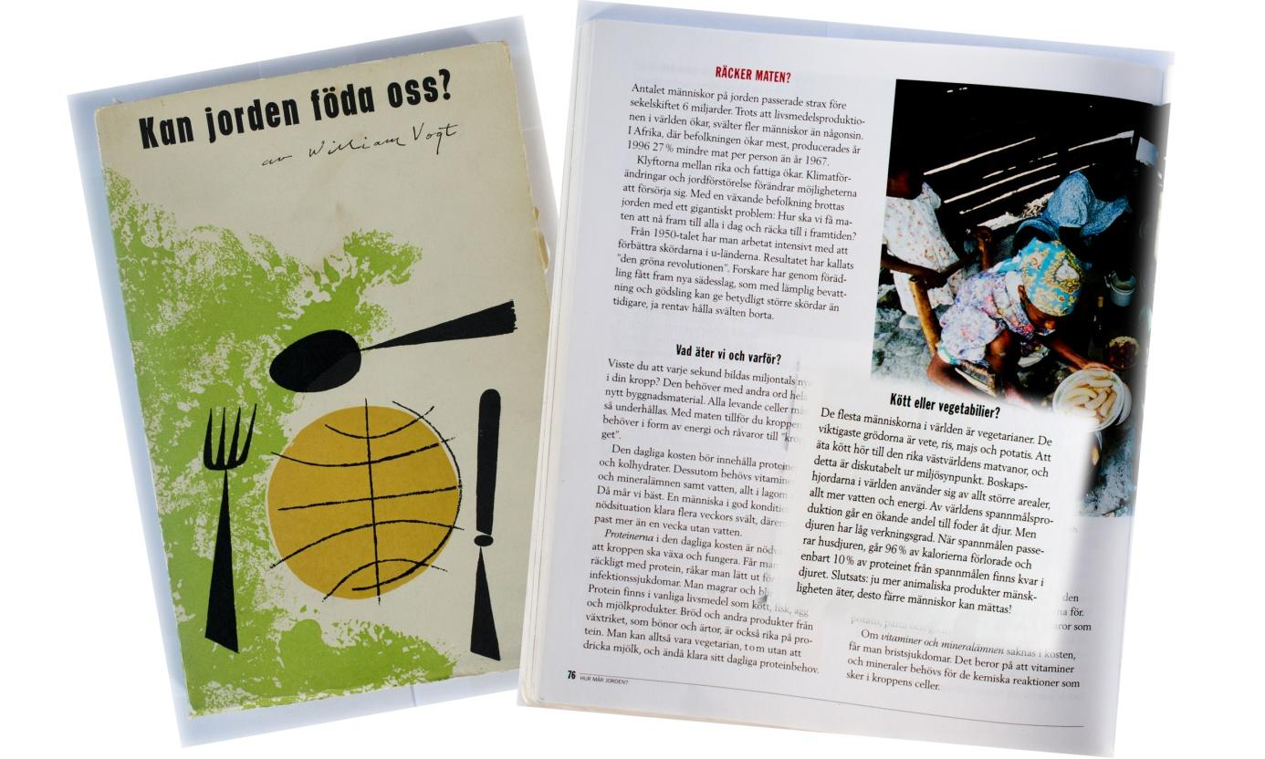
1948 the American ecologist William Vogt wrote the book: Can the Earth feed us? The author was concerned that the global population was so big that they were right on the edge of having an adequate food supply. He argued that we need to stem population growth otherwise there would be a disaster. It is 72 years ago William Vogt since wrote this. At that time, the world's population was about 2 billion. We are now 6.48 billion.
The question of human food supply is still under discussion. In the textbook, Medan Jorden Snurrar for Natural Science A, there is a chapter called: Enough food? When the text was written, the number of people on earth had passed 6 billion. Below is a paragraph from the chapter:

"Meat or vegetables
Most people in the world are vegetarians. The main crops are wheat, rice, corn and potatoes. Eating meat is one of the rich Western diets, and this is questionable from an environmental perspective. Cattle herds in the world use larger and larger land areas, more water and energy. An increasing proportion of the world's cereal production is used to feed animals. But the animals have a low efficiency. When the grain is passing through animals, 96% of the calories are ‘lost’ and only 10% of the protein from the grain remains in the animal. Conclusion: the more animal products mankind eats, the less people can be satisfied (Medan Jorden Snurrar, 2000, p 77)
1. Discuss the paragraph ‘’Meat or Vegetables’’ together and try to come up with ideas about / understand what the authors mean.

2. The authors state that it is questionable to eat meat from an environmental point of view. Discuss if / why this is questionable from an environmental perspective, based on your knowledge about, for example, ecology and environment.

3. Is the conclusion: "the more animal products mankind eats, the less people can be satisfied!" coherent?
Discuss.

4. Imagine that a political party in the town has suggested that it should serve more vegetarian food in the town’s schools for environmental reasons.
You are now a participant in the town’s city council and will debate the issue. First consider what you as an individual think. Then have a discussion / debate about the issues to make a final decision.

Transcript of a student discussion

Mona: Discuss the section ”Meat or Vegetables” together and try to understand the author’s intentions.

My: Well, I didn’t know that most people were vegetarian!
Mona: Nope.
Alex: Really, most people are?!
My: It’s still good to be vegetarian.
Mona: Yeah?
My: Isn’t it better, because vegetables, you can grow really simply. It’s a bit more difficult farming animals.
Mona: That conclusion .. ”the more animal products people eat, the fewer people can...” [”be fed.”]
Mona: What do they mean?
My: Yeah, that, errh.
Mona: In India and so on they don’t just eat like .. um .. mashed potatoes.
My: Mashed potatoes?! [Surprised]
Mona: Nah, I don’t know but...
My: Not potatoes but mashed ones?
[Laughter]
Mona: No, but if you look at like Africa, save the children [UNICEF] then they all drink, like, formula.
My: But here, listen.. ”when the grain passes through the cattle, 96% of the calories are lost and only 10 % of the protein remain in the animal.”
My: No idea what that means?
Mona: Well, that, they defecate 96% of it, or what?
My: Is it just that, it disappears to nothing. And then we can use, like, 10%, because it turns into meat and like that stuff, or what?
Mona: Or whaat?
My: I don’t get it.. ”the more animal products...”
Mona: ” When the grain passes through the cattle ” [reading]. That they eat grain or what?
My: I don’t know.
Mona: I don’t understand.
My: ”The more animal products people eat, the fewer people can be fed”
Mona: Can’t she [the teacher] come now.

[small talk while waiting for the teacher]
My: Could you like, help us get started?
Teacher: Which one are you working with?
My: Number one.
Teacher: What are they saying? What does that say?
Mona: Yeah, they are saying that, well that it is good to be vegetarian. No, I don’t know.
Teacher: And why is that?
My: Because you need so much food to give to the animals, maybe?
Teacher: Go on. [Laughter]
My: And then it’s more worth it to ..well. We need to give the animals tonnes of food, because we want to grow them big and fat for their meat. And then it wastes so much of the food, because it says right here, that.. this. [pointing to the text]
My: That 96% of the calories are like, just lost. So we are throwing away a lot of food. The kind of stuff that we could normally eat.
Teacher: What are you thinking? Are you making the same interpretation as…? [Asking the others]
Alex: Yeah.
My: I think it was very good.
[Reading Question 2]
Mona: But there are still animals. Then we might as well eat them!
My: Yeah, but, it is unnecessary with this mass-.. this mass-[production] . They give animals all this food so that they will become fat so then we will have a lot of food.
Mona: But like on that movie then.
My: Yes, exactly. That was what I was thinking. It’s unnecessary to give them that much food instead, we could eat that ourselves!
Mona: So we throw away a lot of food that we could eat. And then animals get to suffer.
My: Yeah, and we get to suffer as well because they then cut down the rainforests to get places for animal production and then the ozone layer gets destroyed and so on...
Mona: Screw meat!
Alex: No.
My: It tastes good.
Mona: I know that it tastes really good.
My: You kind of hunt elk, because there are too many otherwise, and then we can, like, eat that.

Mona: Mm.
Mona: Let’s do the next one then … ”is the conclusion correct that: ‘The more animal products people eat, the fewer people can be fed!”. Discuss.
My: Don’t know
Mona: Yeah, but it’s true, isn’t it?
My: ”The more animal products people eat, the..”
Mona: So, if we would.
My: Yeah.
Mona: To produce more of these animals. It would take more of the grain and all.
My: [Simultaneously] Yes, because, exactly what we give them is more food than we get out of them.
Alex: Then we really lose out on it.
My: Yeah, what we feed the animals. That could feed more people than the little that...
Alex: Yeah, we are throwing away quite a bit in that case.
My: But, I’m sure that those people owning the cows make a tonne of money, because meat is that much more expensive than all of that. So it’s profitable.
Mona: Yeah, that’s why they do it. Then they sort of continue like that.
My: Yeah.
Mona: How are we going to stop it then?
Mona: We simply boycott meat.
Alex: No, I don’t agree with that.
My: No, because meat is tasty.
My: Let’s take the next one.
My: Imagine that a party in the city has proposed serving more vegetarian food in the city schools for environmental reasons. You are now participants in the city council and need to make a decision on the matter. First contemplate what you as an individual think about it, then debate the issue to reach a conclusion.”
Mona: Yeah. [Carefully]
My: That would be very good! I think.
Mona: Yeah [Hesitating] and serve more .. yeah.
Alex: Are you serious, or do you mean instead of normal food, now?
My: Nope, then I don’t think that they should remove meat completely.
Alex: Do they mean that they’ll just increase the vegetarian part?

My: No but, couldn’t they have more. A couple of days a week they could, like, serve only vegetarian.
Mona: What did you say?
My: A couple of days a week they could, they could serve vegetarian, like that.
Mona: Yes.. [doubtful]
My: Then we would still be better off. But then what could happen is, more and more would skip school lunch to eat at like...
Alex: Subway. That isn’t quite vegetarian.
Mona: Nope.
My: We’ll have to eat other things.
Mona: But you still have to encourage people with, like, nice vegetarian food.
[The conversation is going slowly. It the students seem thoughtful]
My: But still, if they served more vegetarian food you would get used to eating it, and then it would, like..
Mona: Mm, but yeah, exactly. It’s just that we are used to eating meat and all now, that’s why we do it. But if we grew up in Africa, we wouldn’t have been eating meat, or? I don’t know.
My: They don’t eat meat in Africa?
Mona: No, well, the poor probably don’t.
My: Not as much.
Mona: No, I don’t know.
My: We are to make a decision.
[The conversation goes more quickly. The task will be solved.]
Mona: Some days a week. [Confidently]
My: What do you say..
[Others laughing]! No.
[Laughter]
Mona: And there we end that discussion.

